CS570 – Software Testing
HOP08B – Selenium WebDriver – Uploading & Downloading Files
11/22/2020 Developed by Kim Nguyen
Center for Information Assurance (CIAE) @City University of Seattle (CityU)

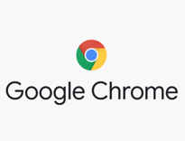

Caution
- If you already finished this module through any CityU School of Technology & Computing (STC) courses, just skim this module and skip it.
- Some version numbers may not match with the newly released ones. If so, stay with the most recent ones.
- This tutorial targets Windows OS and Mac users.
- We cannot explain every step. This cookbook always needs your own creative judgement. Try to solve the problem on your own, after a few tries, if you cannot solve the issue, contact TA for help.

Learning Outcomes
- Deeper understanding of Selenium WebDriver.
- Continue performing web app testing using script, specifically able to:
  - Handling different alert boxes and popup windows
  - Send data to alert boxes

Resources
- Javapoint.come | Selenium WebDriver - https://www.javatpoint.com/selenium-webdriver
- Guru-99 | Selenium tutorial - https://www.guru99.com/selenium-tutorial.html

In this week’s HOP, we will learn how to upload and download files using Selenium

- Move startUsingSeleniumWebDriver project we worked on last week to Module 8 folder.
- In VSCode, open startUsingSeleniumWebDriver folder under the Hands-on Practice folder, the path should be similar to:

CS570-hop-Hands-on-practice/Module8/startUsingSeleniumWebDriver

Uploading Files

- Open this URL, let’s investigate the website before we write our script:
https://testpages.herokuapp.com/styled/file-upload-test.html
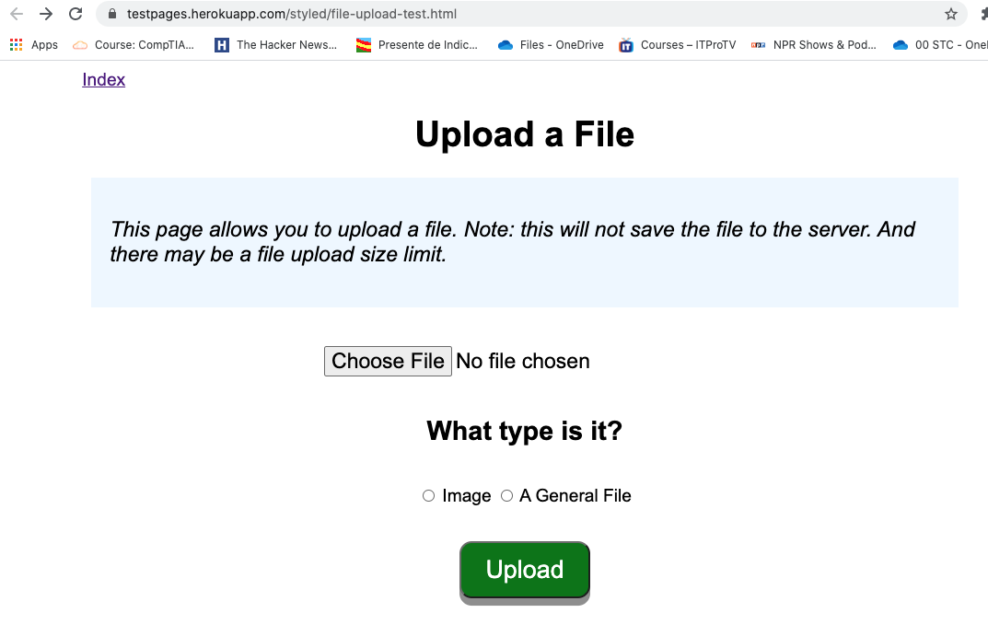

- Try to upload any file and see the outcomes.

- Under webdriver folder, create a new file called “UploadFiles.java”
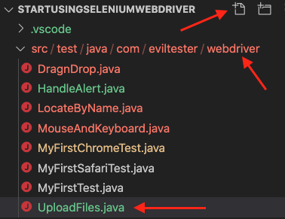
- Type the following into your UploadFiles.java:
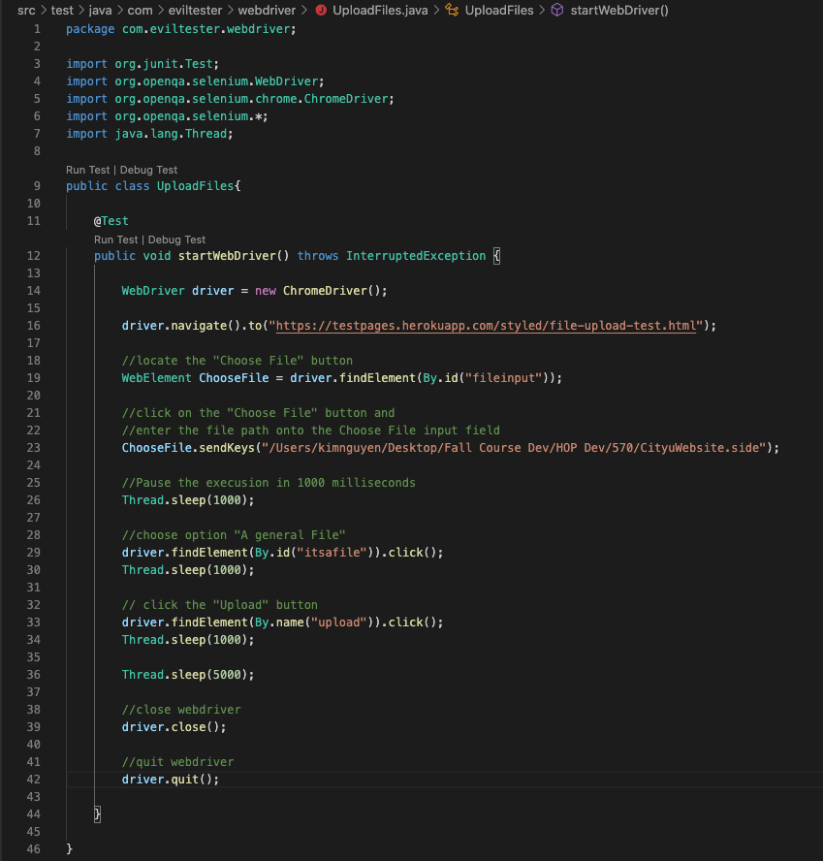

Let’s upload the CityuWebsite.side we downloaded from Selenium IDE in HOP03.

!!! NOTE: Replace the path in line 16 with your actual path, where you store the CityuWebsite.side file. !!!

- Run the test to see result, using the following command:
mvn test -Dtest=UploadFiles.java

(Make sure you are in the right path when running the command. You should be in the startUsingSeleniumWebDriver folder path)

You should see the end result similar to the following:
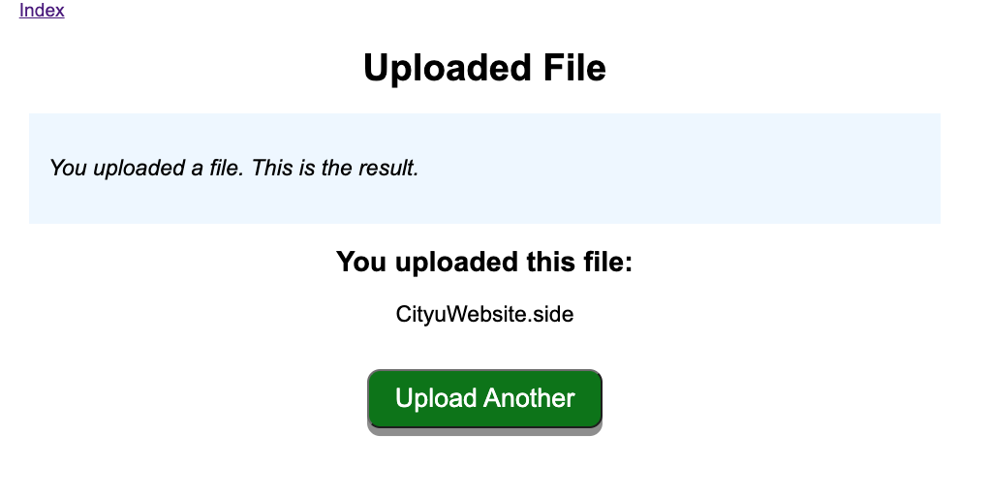

Challenge: The last page we landed after executing our code is as the screenshot above. Add more to your code so that after seeing the above result, the “Upload Another” button is clicked, which then lead us back to the Uploading Page. Expected result similar as following: (notice that our previous actions are still showing on the screen)
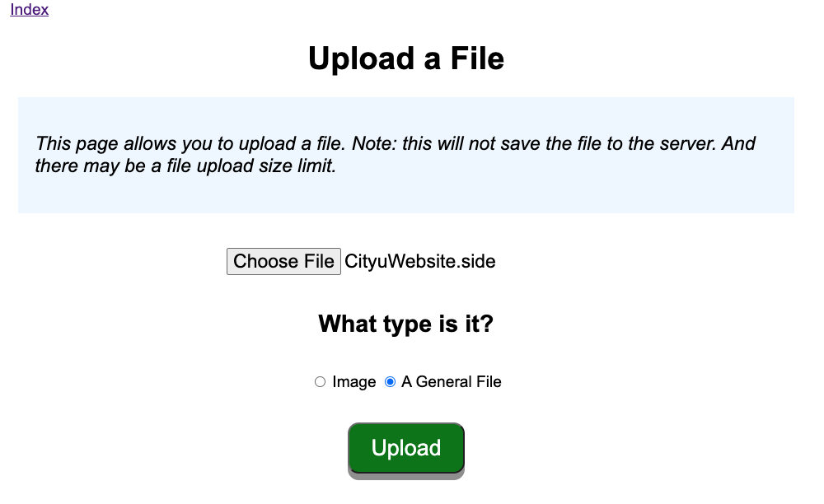

Downloading Files

- Open this URL, let’s investigate the website before we write our script:
https://testpages.herokuapp.com/styled/download/download.html
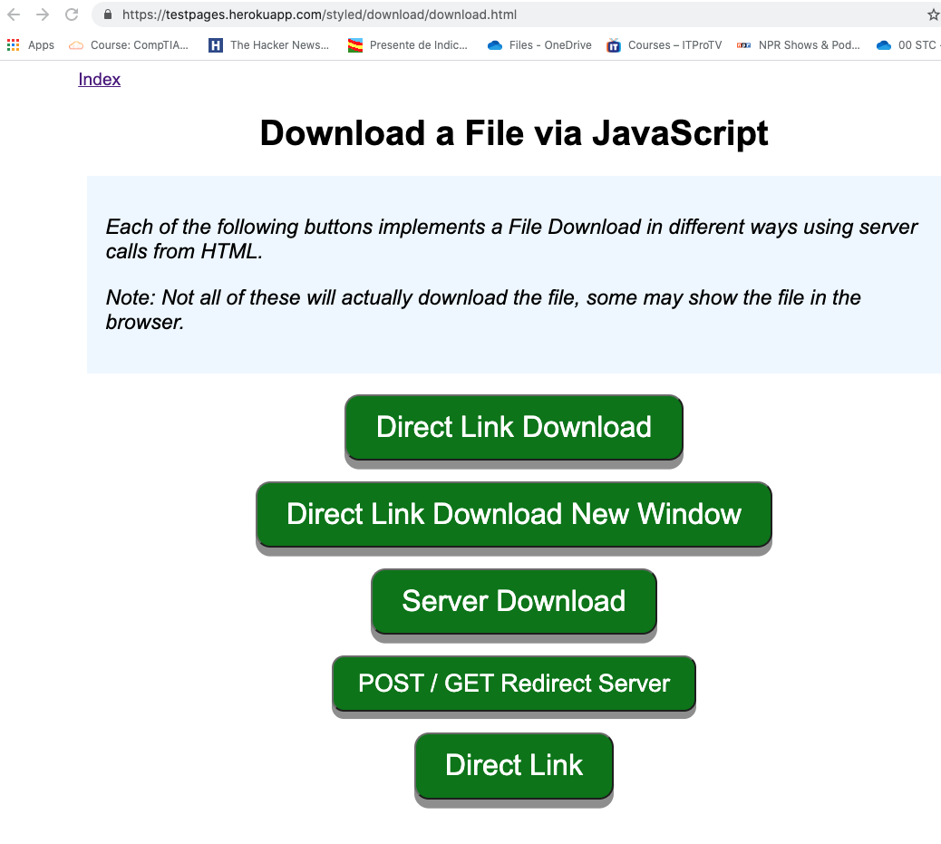
Experiment the page to see what each option does.

Download Files using Wget
- WebDriver cannot automate downloading of files on its own.
- The easiest way to download files using WebDriver is to use Wget.
- Wget is a small and easy-to-use command-line program used to automate downloads. Basically, we will access Wget from our WebDriver script to perform the download process.

If you have not installed Wget, locate the “HOP08A - Installing Wget” document under the same “Module 8” folder. Once done, resume this tutorial.

- Under the same webdriver folder, create a new file and name it DownloadFiles.java 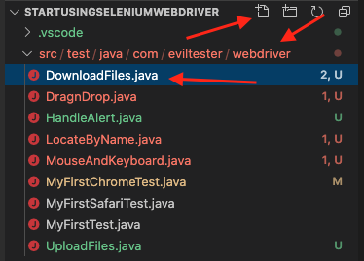
Our target is to download from the “Direct Link Download” button:
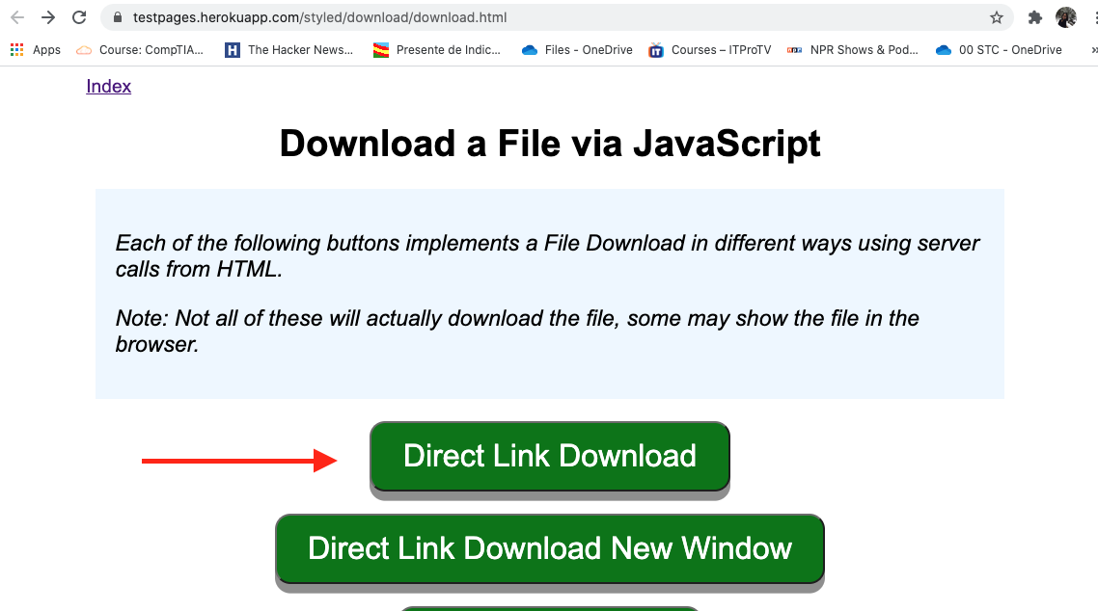
Let’s write the code! Type the following into DownloadFiles.java

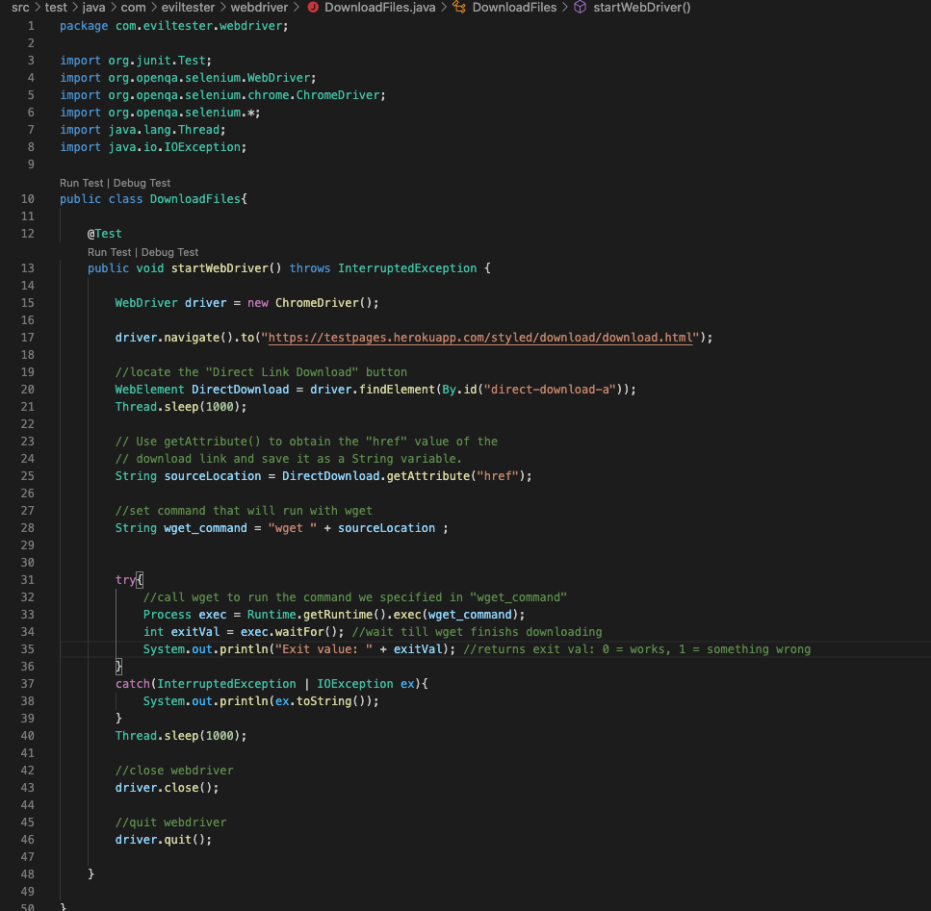

- Run the test to see result, using the following command:
mvn test -Dtest=DownloadFiles.java

After the test has completed executing, you should see the result:
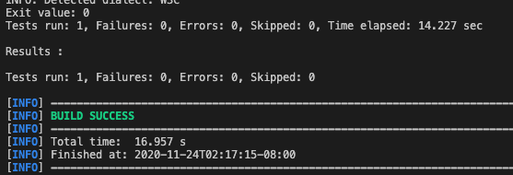

And a file named textfile.txt downloaded to the current working directory(startUsingSeleniumWebDriver)

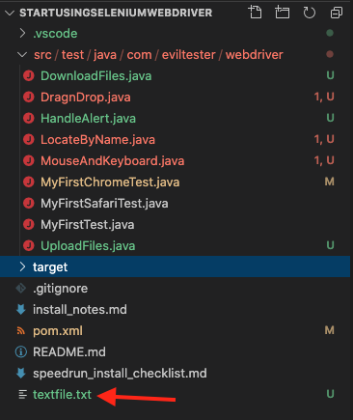

No Challenge for this section

Submit your work:
In VSCode terminal, Type the following command:
- git add . (to copy all changes you have made)
- git commit -m “Submission for Module 8 – Your Name” (To add a message to your submission)
- git push origin master (to upload your work to Github)

